Model Performance Test
Date
26 June 2025
Team ID
111111
Project Name
Classification of Fabric Patterns using Deep Learning

Model Performance Testing
S.No | Parameter | Screenshot / Values
1. | Data Rendered | 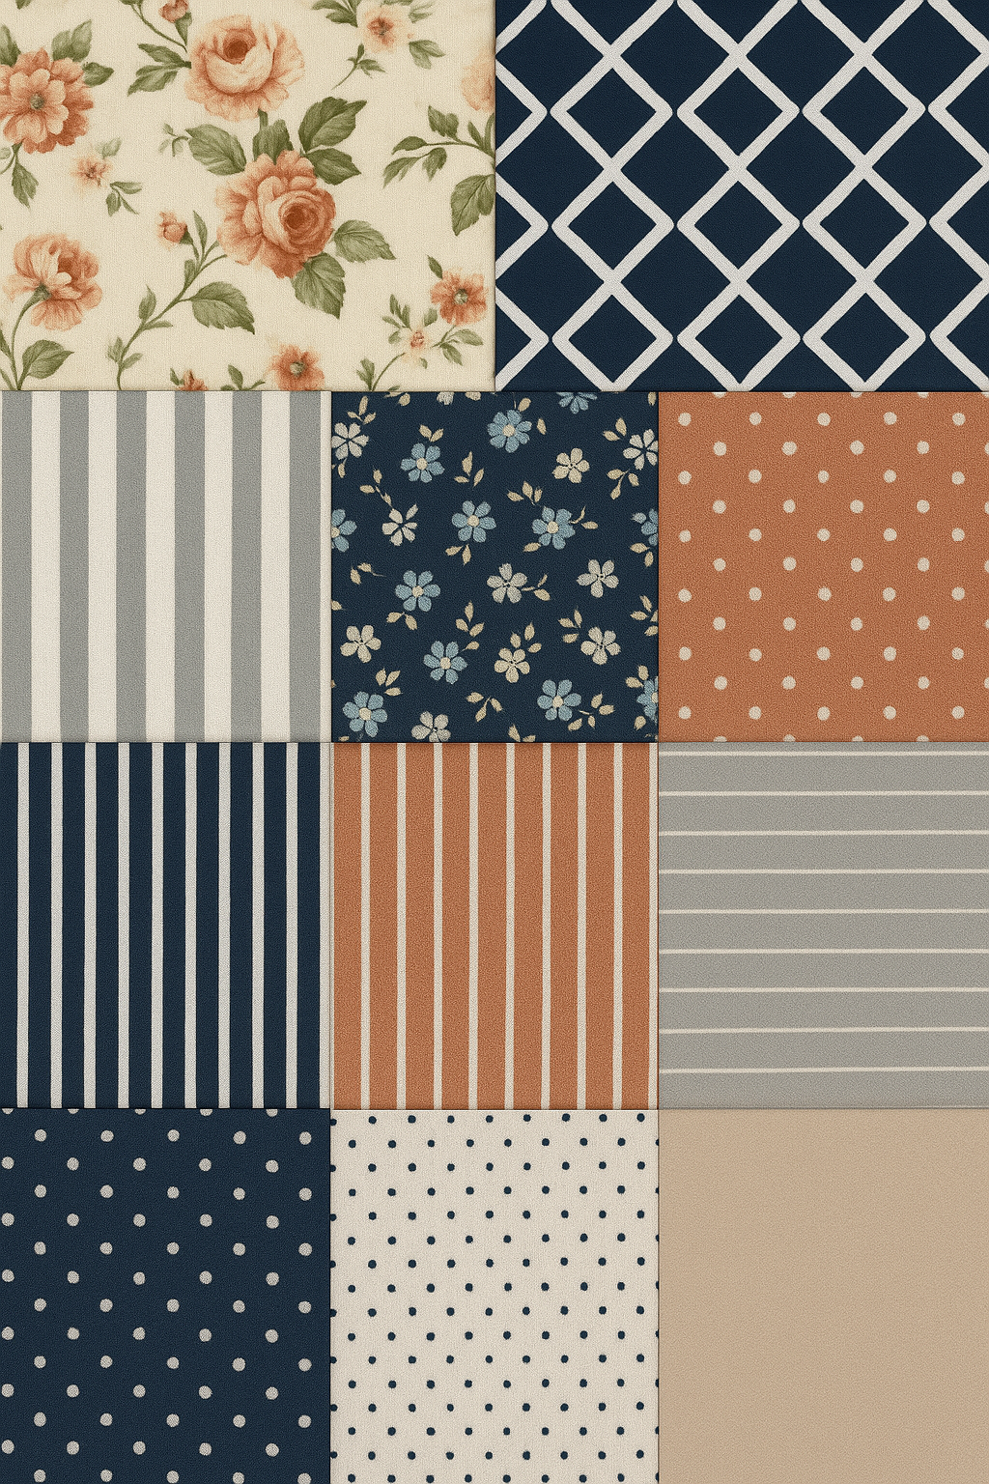  Fabric images rendered from various sources including datasets like FabricNet, Kaggle Fabric Pattern set, etc.
2. | Data Preprocessing | - Image resizing to 224x224  - Normalization  - Augmentation (rotation, flipping)  - Label encoding
3. | Utilization of Data Filters | Dataset split into 80% training, 10% validation, and 10% testing. Noisy or corrupted images were filtered manually.
4. | DAX Queries Used | Not applicable
5. | Dashboard Design | Number of visualizations: 5  - Accuracy graph  - Loss graph  - Confusion Matrix  - Sample predictions  - Class-wise accuracy
6. | Report Design | Number of visualizations: 5  Structured analysis of model architecture, dataset insights, model evaluation metrics

